# Implemented Swing interface

This interface is the main form, which allows a user to update, create, delete and retrieve data about an employee. The swing interface makes it easy and accessible for the user to input data, look at data already in the database, navigate through each employee and delete an employee.

## Create

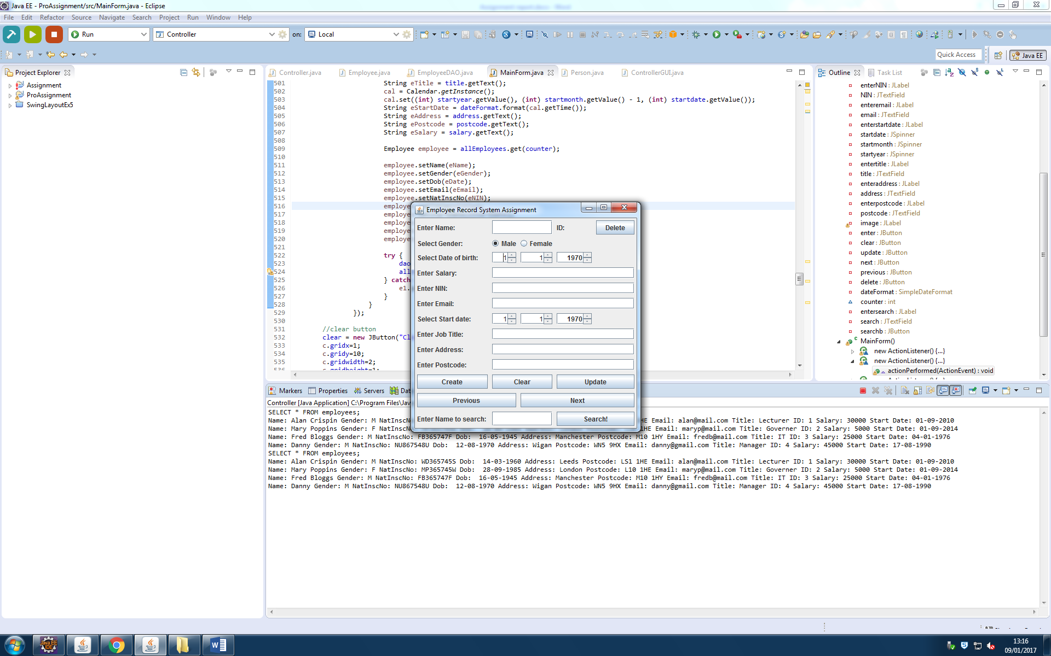The create function allows a user to enter a new employee into the database by filling in each field and clicking the enter button.

## Update

The update function allows the user to update an existing employee records by changing any fields and hitting the update button.

## Delete

The delete allows the user to delete a record from the employees table, by pressing the delete button.

## Retrieve

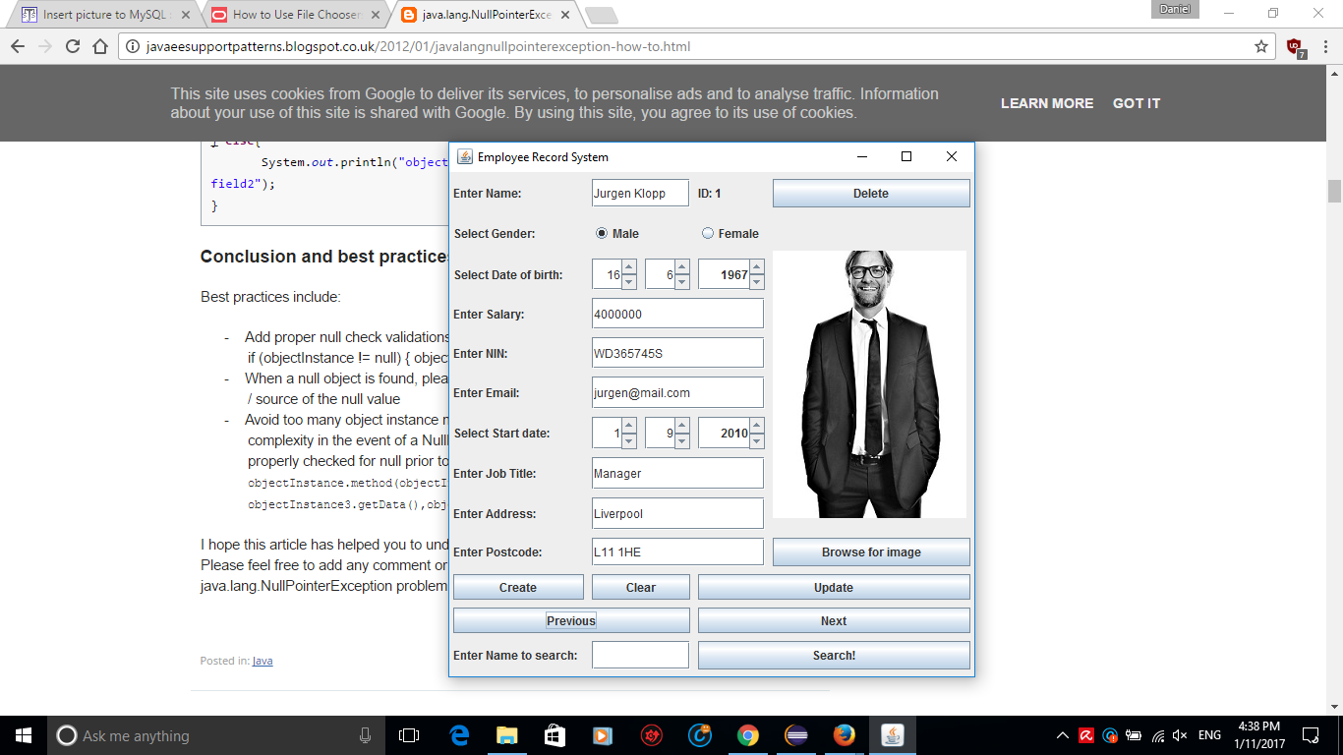A user can navigate through employees that are already in the database. A user can do this by either pressing the next button or by pressing the previous button.

## 

## Search

A user can search for an employee by typing an employees’ full name into the search bar.

## Clear

A user can clear the form so that they may enter information into it, to submit.

## Validation

## Length of name

An error message pops up if the user enters a name under 1 character and more than 45 characters

## 

## Characters for name

If a user enters a character that is not a letter when entering a name, they will receive an error stating that only letters may be used.

## Date checking

If a user enters a date of birth that is after the Starting date of the job, they will receive an error message stating that the date of birth must be before the starting date of the job.

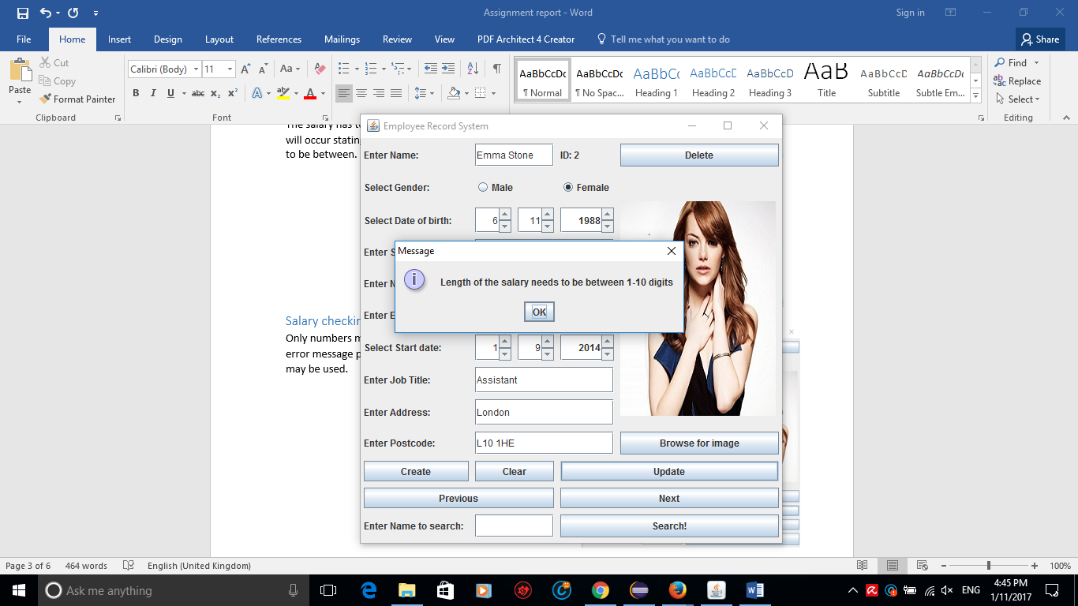

## Salary digit length

The salary has to be between 1-10 digits otherwise an error will occur stating what the amount of digits entered needs to be between.

## Salary checking for numbers only

Only numbers may be used to enter a salary, otherwise an error message pops up telling the user that only numbers may be used.

## 

## NIN length

The NIN has to be between 1-10 characters otherwise an error will occur stating what the amount of characters entered needs to be between.

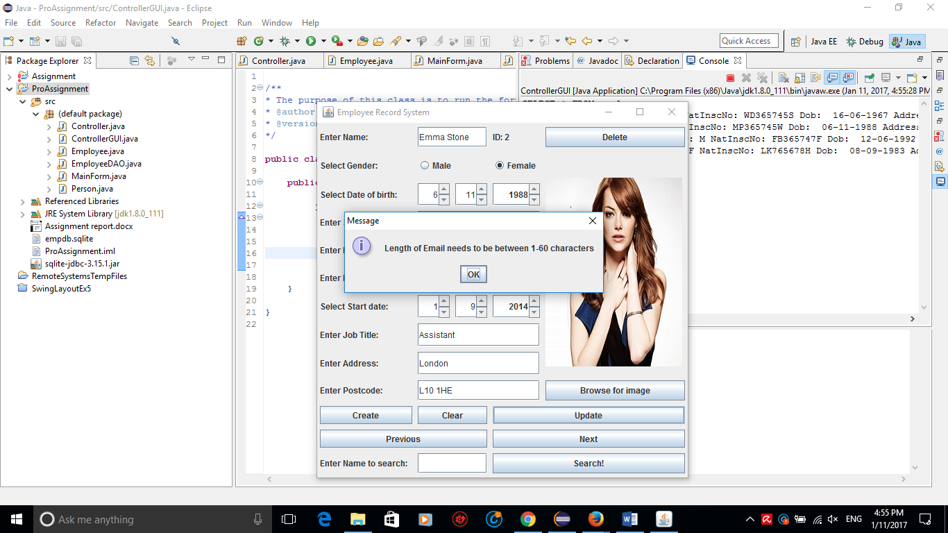

## Email length

The email has to be between 1-10 characters otherwise an error will occur stating what the amount of characters entered needs to be between.

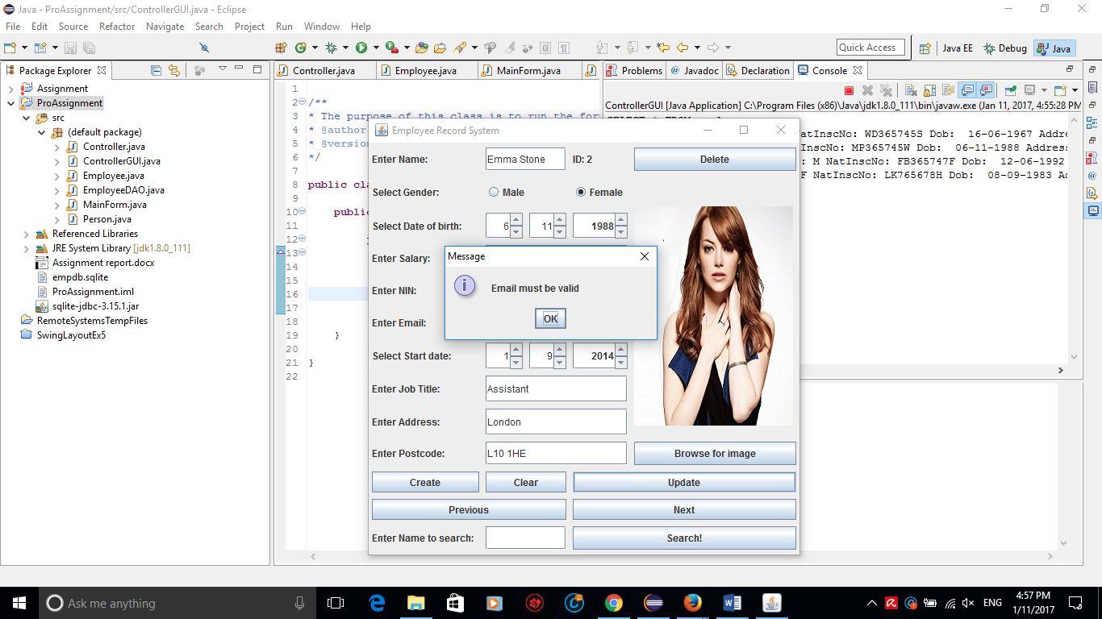

## Email format

If an email doesn’t have text before an “@” and doesn’t have text after it plus a “.” Followed by more text, then the email isn’t valid. A user must make sure to enter an email address in the correct email format.

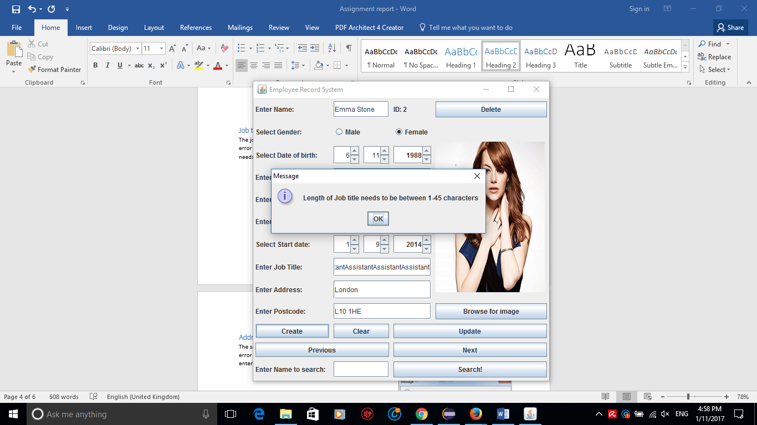

## Job title length

The job title has to be between 1-45 characters otherwise an error will occur stating what the amount of characters entered needs to be between.

## Address length

The salary has to be between 1-60 characters otherwise an error will occur stating what the amount of characters entered needs to be between.

## Postcode length

The postcode has to be between 1-10 characters otherwise an error will occur stating what the amount of characters entered needs to be between.

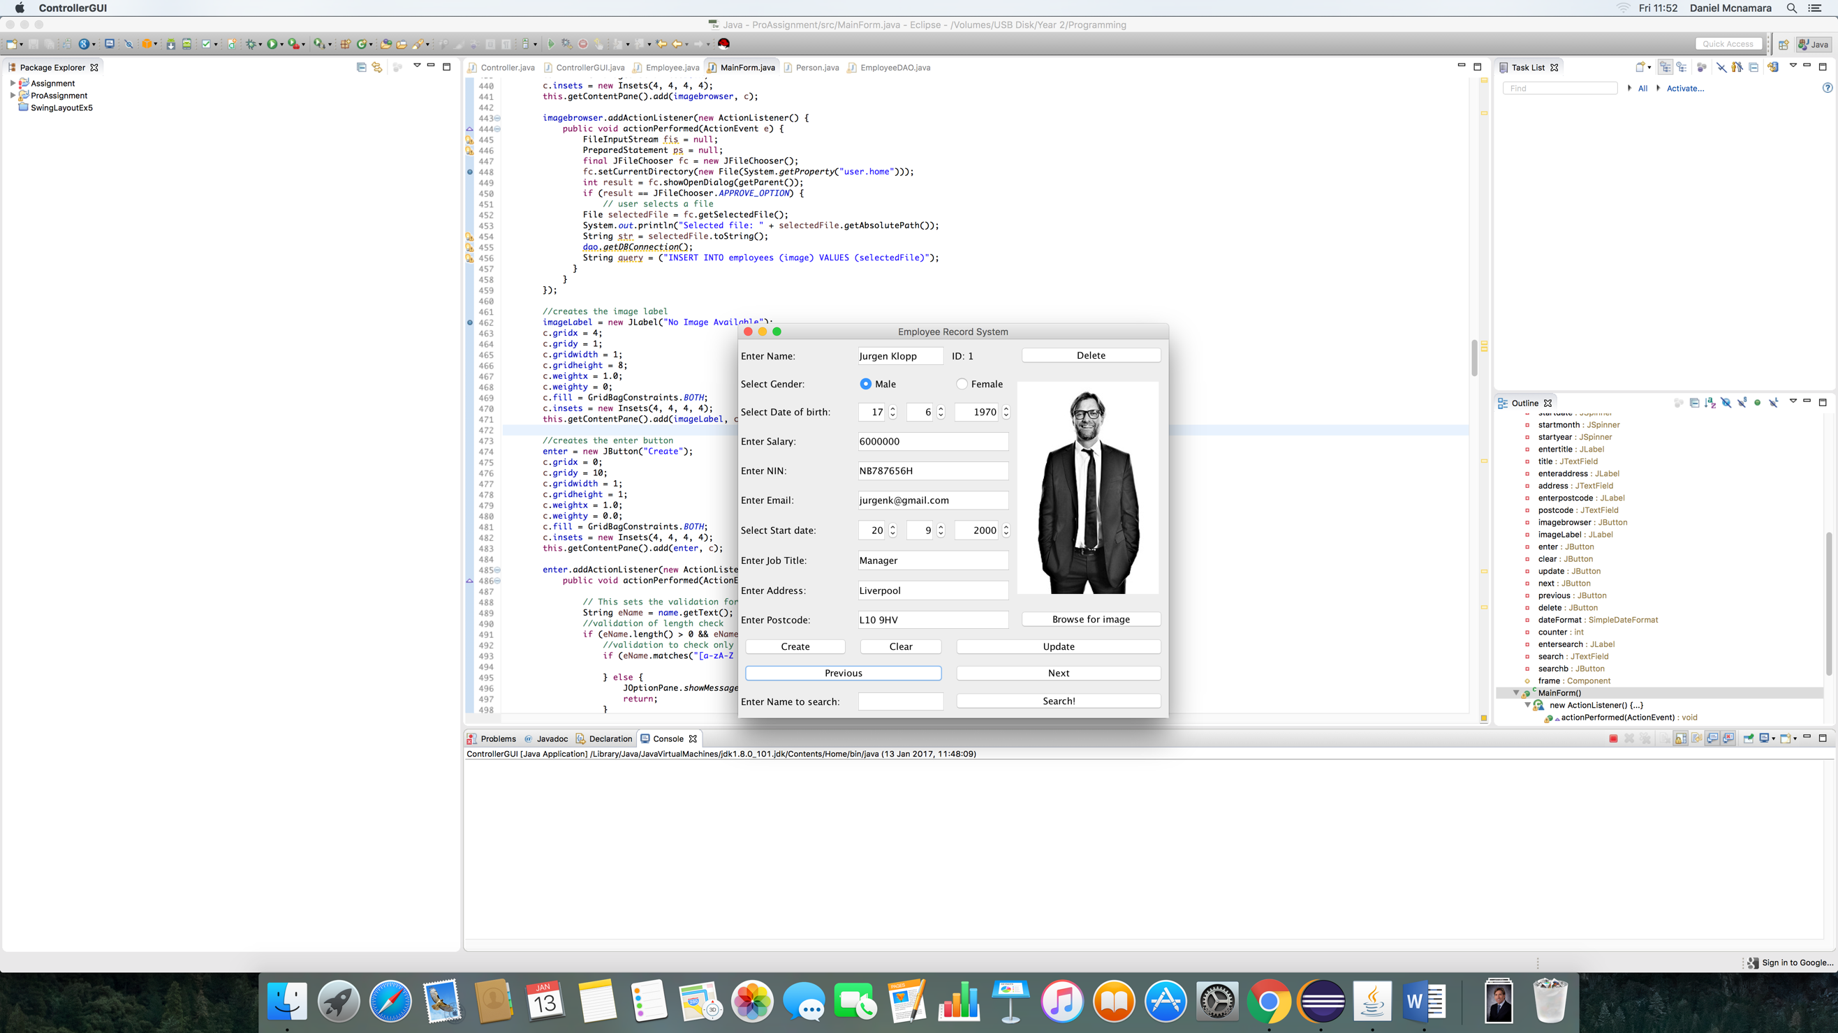

## Displays an Image

An image that is inserted into the database can be displayed on the JFrame form.

## Save an image after browsing

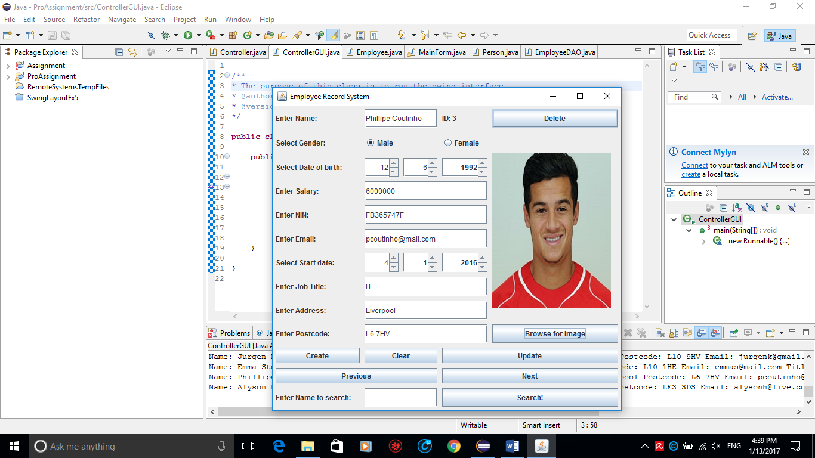If a user wants to select a photo, the “browse for image” button will open a file chooser, to select the photo of choice. 

## The file chooser

When the “browse for image” button is pressed, a file chooser opens up allowing the user to choose an image then press the update button to change it in the database.

